CSA5103-Cryptography And Network Security
Experiment 2
Aim:
To write a Python program to implement the Monoalphabetic Substitution Cipher, where each plaintext letter is replaced with a unique ciphertext letter using a substitution key.
Algorithm:
- Start the program.
- Define the plaintext alphabet (A–Z).
- Define a substitution key containing unique letters.
- Read the plaintext from the user.
- Replace each plaintext letter with its corresponding letter from the substitution key.
- Display the encrypted message.
- Decrypt by replacing each ciphertext letter with its corresponding plaintext letter.
- Display the original message.
- Stop the program.
Code:
# Monoalphabetic Substitution Cipher
alphabet = "ABCDEFGHIJKLMNOPQRSTUVWXYZ"
key = "QWERTYUIOPASDFGHJKLZXCVBNM" # Example key
def encrypt(plaintext):
ciphertext = ""
for char in plaintext.upper():
if char in alphabet:
index = alphabet.index(char)
ciphertext += key[index]
else:
ciphertext += char
return ciphertext
def decrypt(ciphertext):
plaintext = ""
for char in ciphertext.upper():
if char in key:
index = key.index(char)
plaintext += alphabet[index]
else:
plaintext += char
return plaintext
# Main Program
text = input("Enter the plaintext: ")
cipher = encrypt(text)
print("Encrypted Text:", cipher)
plain = decrypt(cipher)
print("Decrypted Text:", plain)
Output:
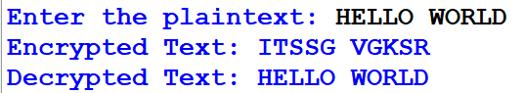
Result:
Thus, the Python program for the Monoalphabetic Substitution Cipher was implemented successfully, and the plaintext was encrypted and decrypted correctly using the substitution key.

